Evolutionary model summary

Wendy Yang

**Goal**

The goal of this rotation project is to explore if we can observe any polymorphism in a two-loci evolutionary model with cyclic selection and phenotypic memory.

**Model description**

Notations

A/a – locus that controls mean variation. A and a are advantageous in different environment.

B/b – locus that controls variance. B – variable phenotype, b - fixed phenotype

Parameters

Smid – mean selective advantage of the alleles

var – variance of phenotype with the same genotype

r – recombination rate

m – mutation rate

N – population size (Assume N is fixed)

p – phenotypic memory

Mutation

Initially I randomly introduced one mutation to locus a or locus b.

For each time step, I have a probability (mutation rate m * population size N) of introducing one mutation at the other locus.

Once mutations happen at both loci, no further mutations are allowed during the simulation.

Selection

The fitness of four alleles in this model is summarized in the table below:

|  |  |  |
| --- | --- | --- |
|  | Environment 1 | Environment 2 |
| ab | 1 - smid | 1 + smid |
| aB | {1 - smid - var, 1 - smid + var} | {1 + smid - var, 1 + smid + var} |
| Ab | 1 + smid | 1 - smid |
| AB | {1 + smid - var, 1 + smid + var} | {1 - smid - var, 1 - smid + var} |

Recombination

Coefficient of linkage disequilibrium D =

fab <- fab – D * r

faB <- faB + D * r

fAb <- fAb + D * r

fAB <- fAB – D * r

Reproduction

To account for the effect of genetic drift, sample the next generation by multinomial distribution.

**Results**

Polymorphism is observed given cyclic selection and phenotypic memory

N = 100000, num_allele = 4, num_steps = 100000, mutation_rate = 1e-5, recomb_rate = 0.5

period = 15, s_mid = 0.4, p = 0.8, var = 0.3

Polymorphism is highly dependent on phenotypic memory

We cannot get any polymorphism at locus b when phenotypic memory is too high or too low.

When p is low, b (fixed phenotype) will be dominant.

When p is high, B (variable phenotype) will be dominant.

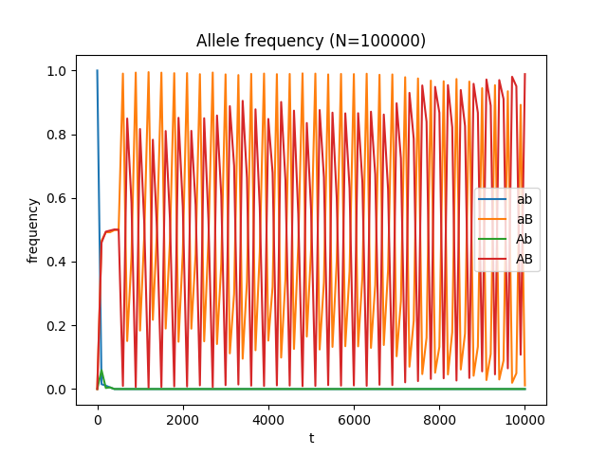

p = 0.2 p = 0.9

Plot for phenotypic memory vs cumulative heterozygosity

